5

Data Analytics Report and Executive Summary

Kiara Angeles Ganger
Western Governor University
D214 | Data Analytics Graduate Capstone

Author Note
The numbers presented in this analysis are scenario-based estimates. They reflect the impact of proposed tariff increases on the Cost of Goods Sold (COGS) for a small business importing from China and Mexico. The scenarios were developed using current tariff rates and projected increases (e.g., 10%, 20%, and 30%) to model potential outcomes. These projections are hypothetical and intended for analytical purposes only.

Research Question:

Summary and Justification of Research Question
How will the proposed tariffs impact the cost of goods sold (COGS) for a small company importing from China and Mexico?
I chose this research question to perform my capstone on because it is relevant to recent global trade developments in the past few months. Tariffs directly affect the cost structures of businesses that rely on imported goods. Small businesses are hurt the most by these changes because they often operate on tight margins. Understanding how proposed tariff increases affect the COGS can provide them with actionable insight to make any adjustments needed to their business's everyday routine.
In recent months the United States has proposed a tariff increase on goods imported from many countries. The highest is China with an almost high of 60% to 100%, which could potentially cause an increase in prices for consumers (Zahn, 2024) and Mexico looking at an increase of 25%. (Horsley, 2024). These changes could significantly increase costs for businesses that depend on these imports, which will then have a downstream effect on consumer pricing and market competitiveness.
The null and alternate hypotheses for this report are:
- Null hypothesis-. Tariffs on goods imported from China and Mexico do not significantly impact the company’s COGS
- Alternate Hypothesis- Tariffs on goods imported from China and Mexico significantly impact the company’s COGS.

Data Collection

Relevant Data Collected
The data collected for this analysis was collected from two sites: Harmonized Tariff Scheduled(HTS) of the United States and USITC DataWeb:
- Annual Tariff Data for 2023 (Annual Tariff Data, 2023, [Dataset], 2024):
This dataset gives detailed information on tariffs applied to goods imported to the US. Including specific and ad valorem rates for goods coming from Mexico and the MTNs(which includes China)
- Additional Tariffs (Harmonized Tariff Schedule, 2024):
This dataset is a supplemental listing of the extra tariff imposed on China in subchapter III, Chapter 99 marked with code (.1) of 7.5% or 25% (Harmonized Tariff Schedule of the United States, 2024).
One advantage of the data-gathering methodology was using government-based public data. This dataset is full of up-to-date information, has detailed tariff rates segmented by product categories, and is an official HTS set. This will ensure that the analysis stays relevant.
One disadvantage of the data-gathering methodology was the complexity of aligning datasets from various sources. The discrepancy in the HTS8 codes required that I preprocess the data before the datasets could be combined. Another one was the tariff structures. Like Chapter 99, which included adding an increase of 7.5% to 25% to certain codes for Chinese imports and filling in the rates for Mexico to match the MFN rates since they only filled it if the rate was different while making sure to identify if it had a special a rate when the identifier S was in column ‘col1_special_text’.
One of the biggest challenges was the unavailability of specific COGS data for small companies importing from China and Mexico. To deal with this issue, I created a hypothetical COGS column. This will allow for the simulation of various scenarios and the assessment of tariff impacts on COGS. Allowing me to move forward with the analysis even though I do not have the real-world company data available. The idea came from an article that spoke about using a cost simulation model (Cost of Goods Sold: How to Use Cost Simulation Model to Calculate the Cost of the Inventory That Is Sold During a Period, 2024).

Data Extraction and Preparation

Summary of Data Cleaning
For this analysis, I used R and R Markdown to extract and prepare the data. R Markdown is similar to Jupyter Notebooks, it lets me run codes section by section with the provided output, and a section for narrative text within a single document.
Tools and Techniques Used:
I started by importing all the R packages and libraries I will be using for cleaning.
- Readxl allows the program to read Excel files and readr reads CSV files.
- Dplyr provides a set of functions, known as "verbs," for data manipulation like filtering rows, selecting columns, arranging data, and creating new variables.
- Tidyr helps ‘tidy’ the data, where each variable has its own column, each observation has its own row, and each value has its own cell (GeeksforGeeks, 2023).
- Stringr offers a set of functions designed to make working with strings (text data) as easy as possible.
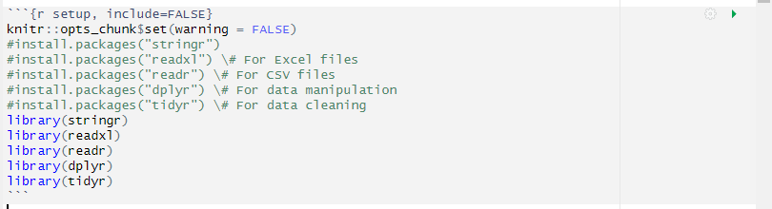
Data Loading
I then loaded the two datasets from HTS and DataWeb using the read_excel() function. Using the Head function to see the first 6 rows of each dataset:
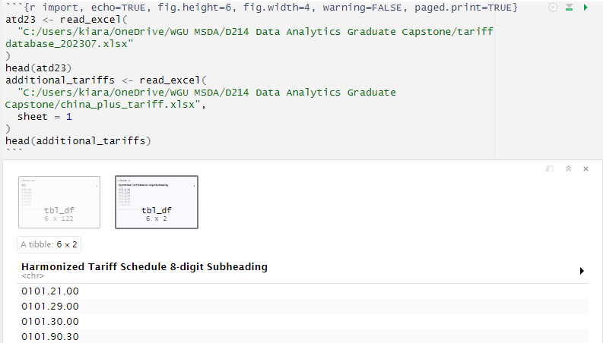
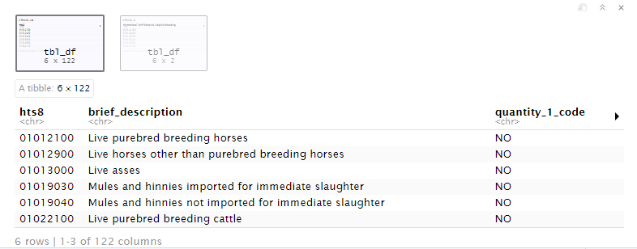
Data Cleaning Process
To clean the data, I
- Renaming Columns
I renamed the columns in the additional dataset table from Harmonized Tariff Schedule 8-digit Subheading and Applicable Subchapter III, Chapter 99 Heading to hts8 and chapter99_code, respectively.
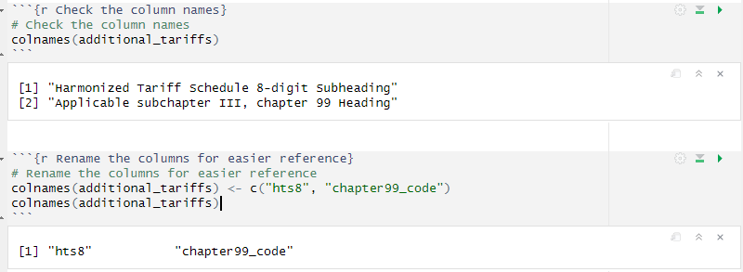
- Column Selection
From the atd23 dataset and determined which columns I would be using for the analysis and created a temp table with the selected columns:
hts8 | brief_description | mfn_text_rate | mfn_ad_val_rate
mfn_specific_rate | col1_special_text | mexico_ad_val_rate | mexico_specific_rate
nafta_mexico_ind | begin_effect_date | end_effective_date
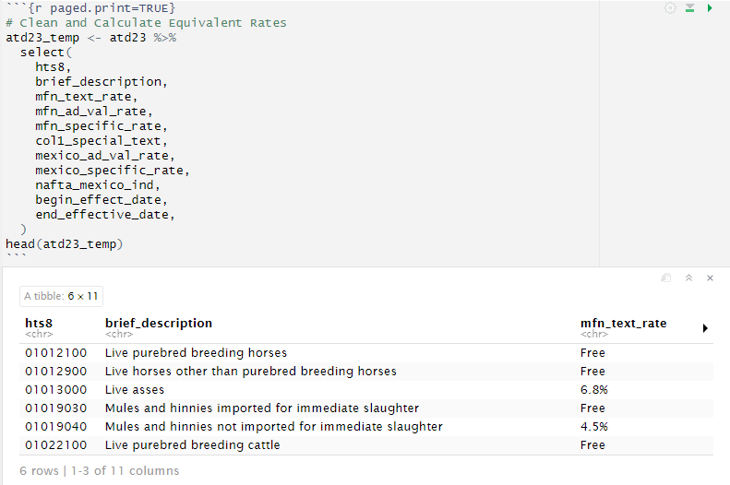
- Joining Datasets
I used a left join with the modified additional tariff table, by first removing the periods in the hts8 code on the additional tariff table so that they match on both tables.
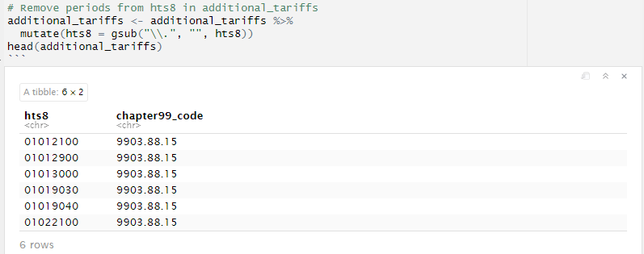
- Filtered Unnecessary Rows
I removed all rows that began with 98 and 99. These were rows pertaining to chapters 98 and 99 and are not needed anymore since I’ve added the additional charges to the columns pertaining to China. I then combined the additional tariff table with the atd23_temp table. Using a left join on the hts8 codes.
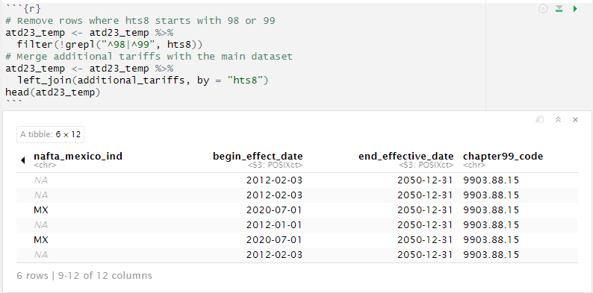
- Adding China-Specific Columns
I then made the columns for China using the MFN columns and added the additional rates from chapters 98 and 99 pertaining to them.
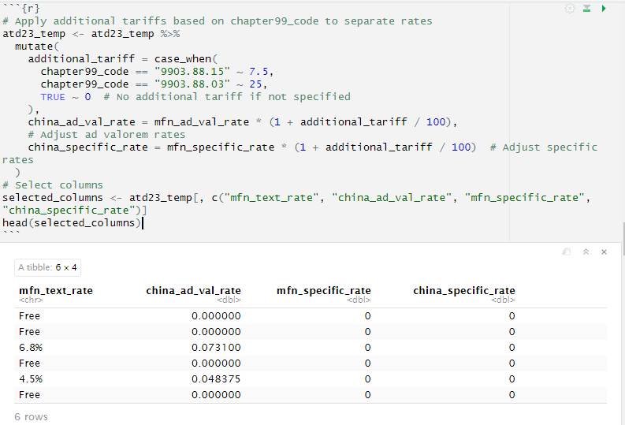
- Handling Missing Values for Mexico
I then took care of all the missing values for Mexico, based on their code on the col1_special_text column, Mexico is represented by the code S. For example, if the line says Free (A*, AU, B, BH, C, CL, CO, D, E, IL, JO, JP, KR, MA, OM, P, PA, PE, S, SG) the rate for Mexico will 0. Then check to see if there were any NA values left.
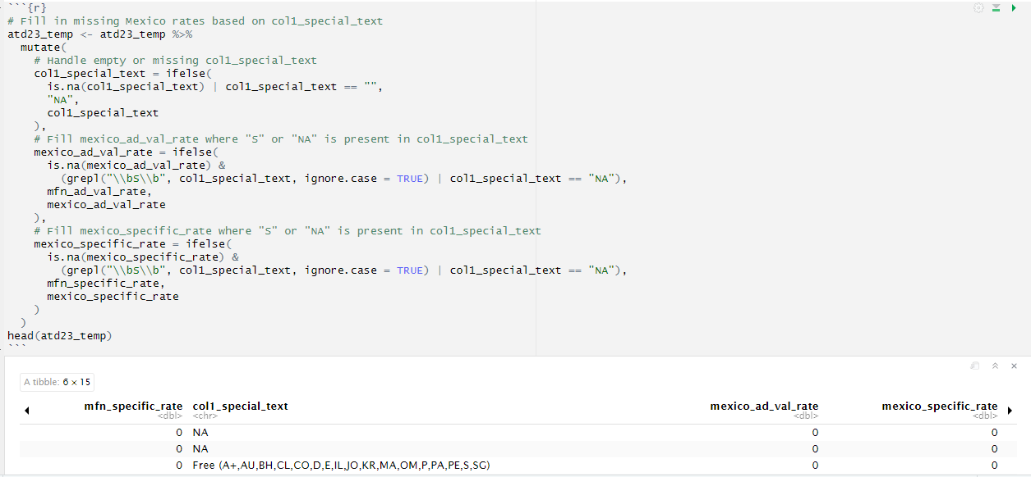
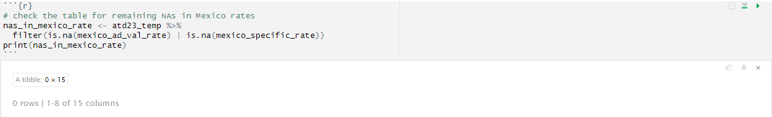
- Creating the section column
Here I created the sections for each chapter group. This will make the analysis much easier to understand and group everything by type.
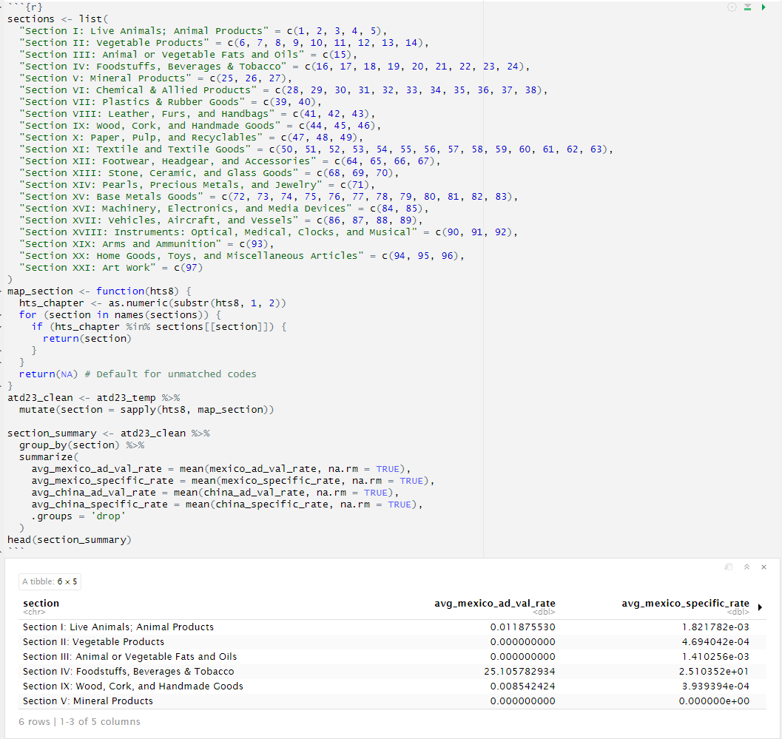
Justification
The advantage of using R is that it has data manipulation libraries like dplyr and tidyverse. These libraries make cleaning datasets simpler, and which improve the speed and accuracy of data cleaning and transformation. R Markdown allows me to integrate my code, output, and explanation all in one document. Making for less files to open and more user-friendly access.
One disadvantage is that R can be resource-intensive when processing large datasets because it loads data into memory. This can lead to performance issues, such as slow processing times or even crashes, especially on systems with limited memory.
With the data cleaned and merged, I proceeded to analyze the impact of increased tariffs through scenario-based modeling and calculated average rates across product sections. Below are the analysis techniques and outputs.

Analysis

Data-Analysis Process
In the data analysis process, I used the scenario-based modeling approach to assess the impact of increased tariffs on the Cost of Goods Sold.
Scenario Analysis
For the scenario analysis, I created columns to simulate tariff increases of 10%, 20%, and 30% for both ad valorem (percentage-based) and specific rates. This allowed for a comparison of potential tariff scenarios on goods imported from China and Mexico.
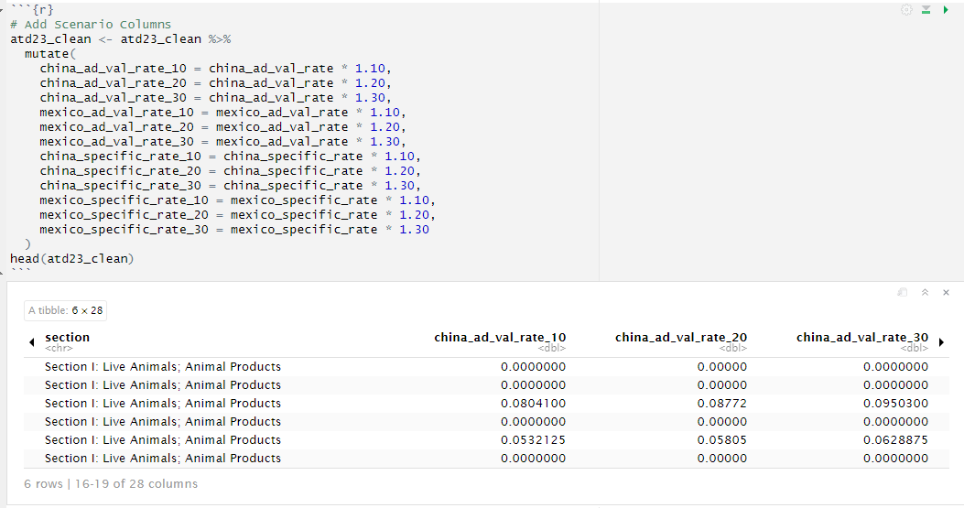
Aggregating Results:
I then grouped the sections as defined in the Harmonized Tariff Schedule and calculated the average tariff rate for each country:
- Mexico: Original and scenario-based rates (10%, 20%, 30%).
- China: Original and scenario-based rates (10%, 20%, 30%).
This allows me to compare by section instead of by line, highlighting the key areas impacted by the proposed increase in tariff rates.
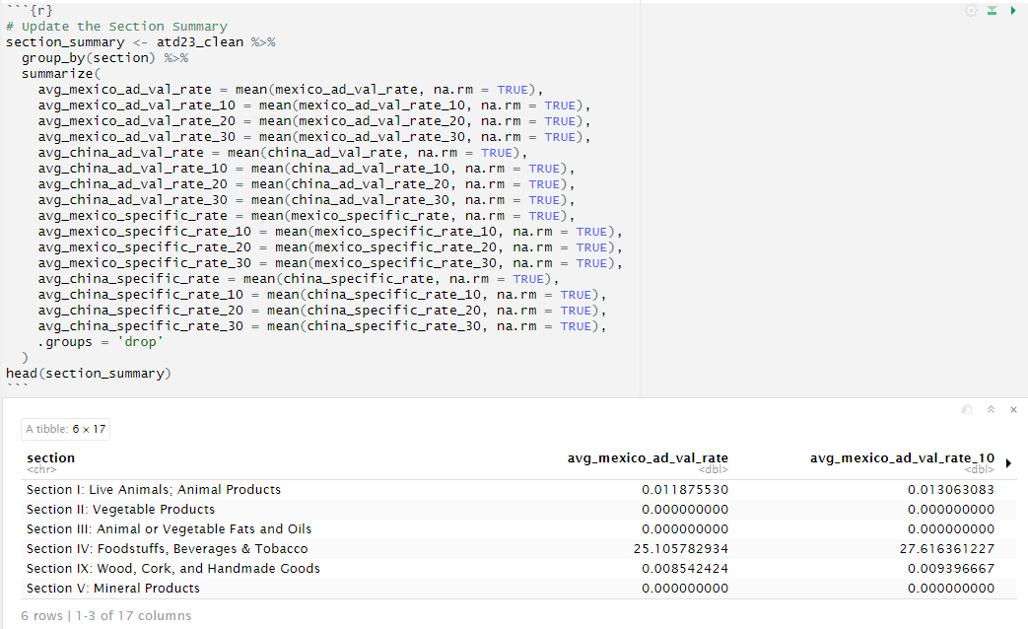
Comparing differences
I calculated the differences between the original and simulated rates. This allowed me to compare the impact of increases within each product section.
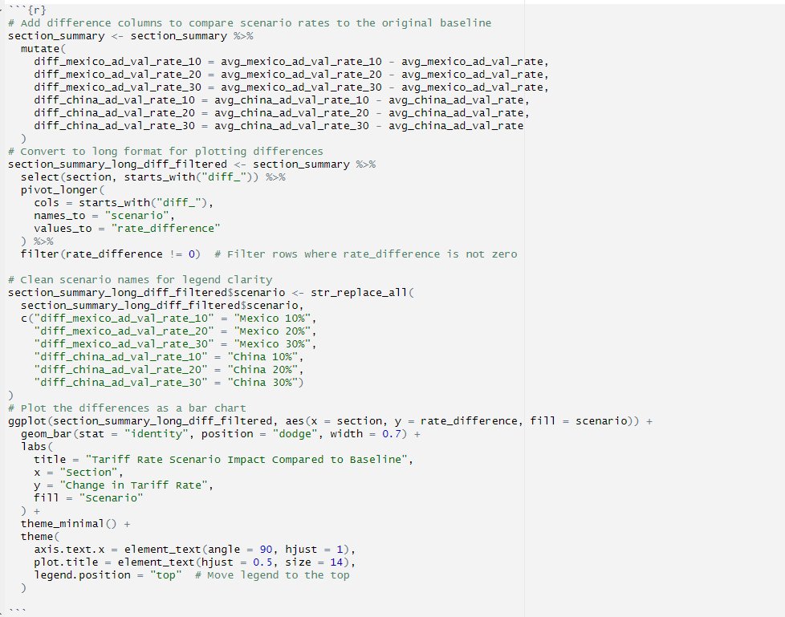
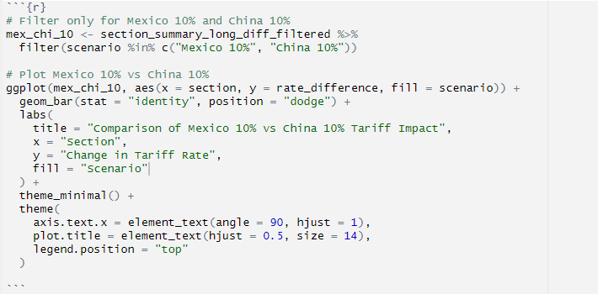
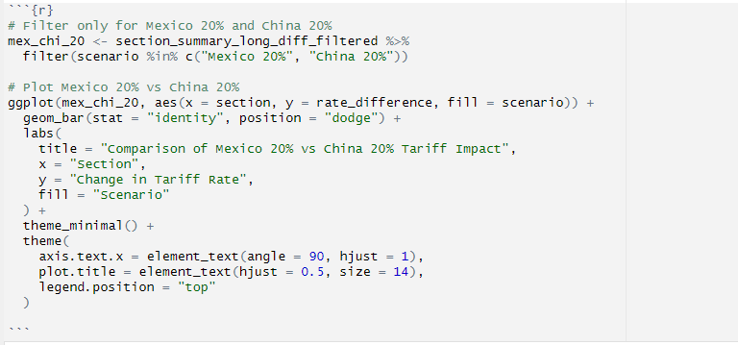
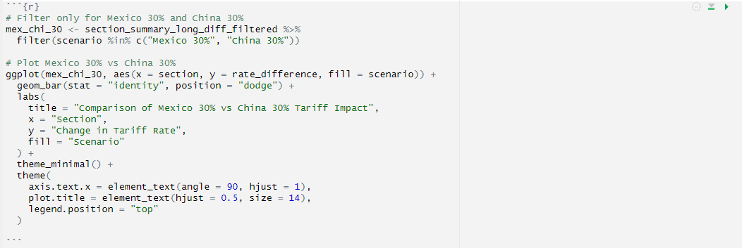

Visual Analysis
- I created charts showing differences in tariff rates compared to the baseline, focusing on sections with significant changes.
- I created bar charts to compare Mexico’s and China’s tariff increases side-by-side for clarity (10%, 20%, and 30%).
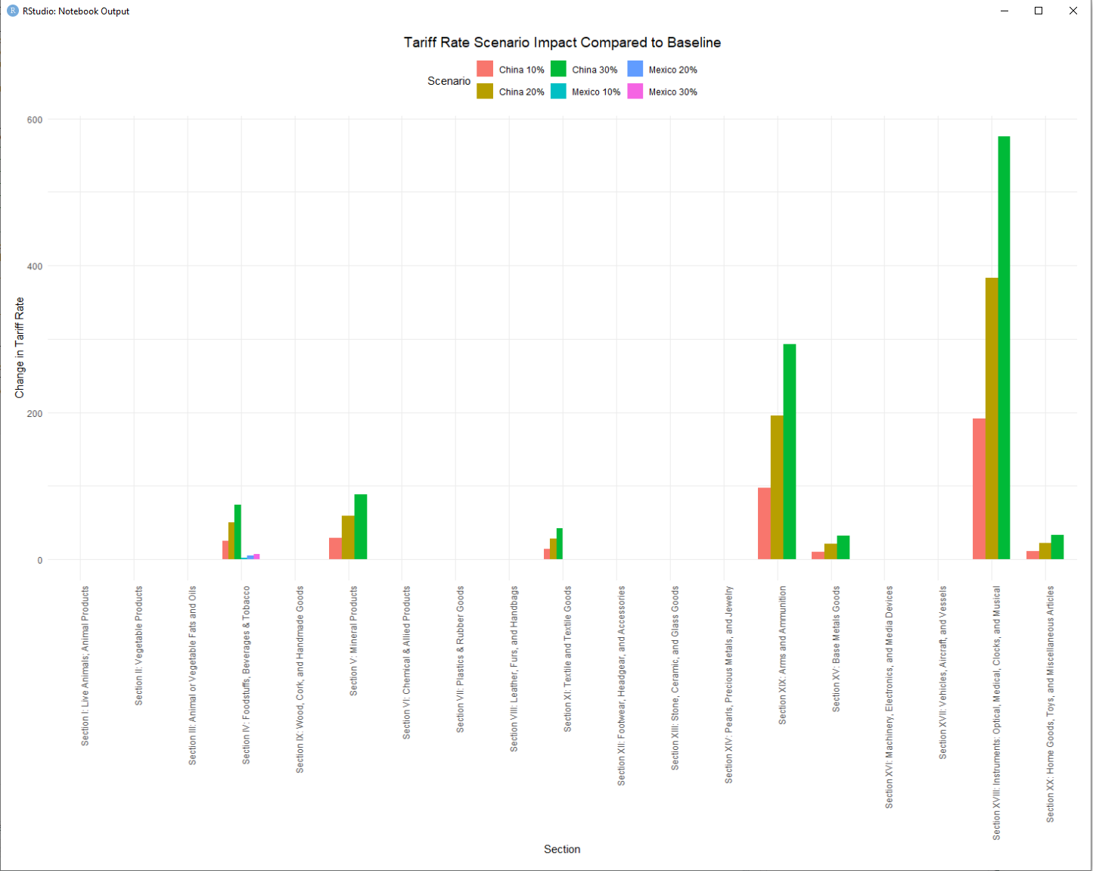
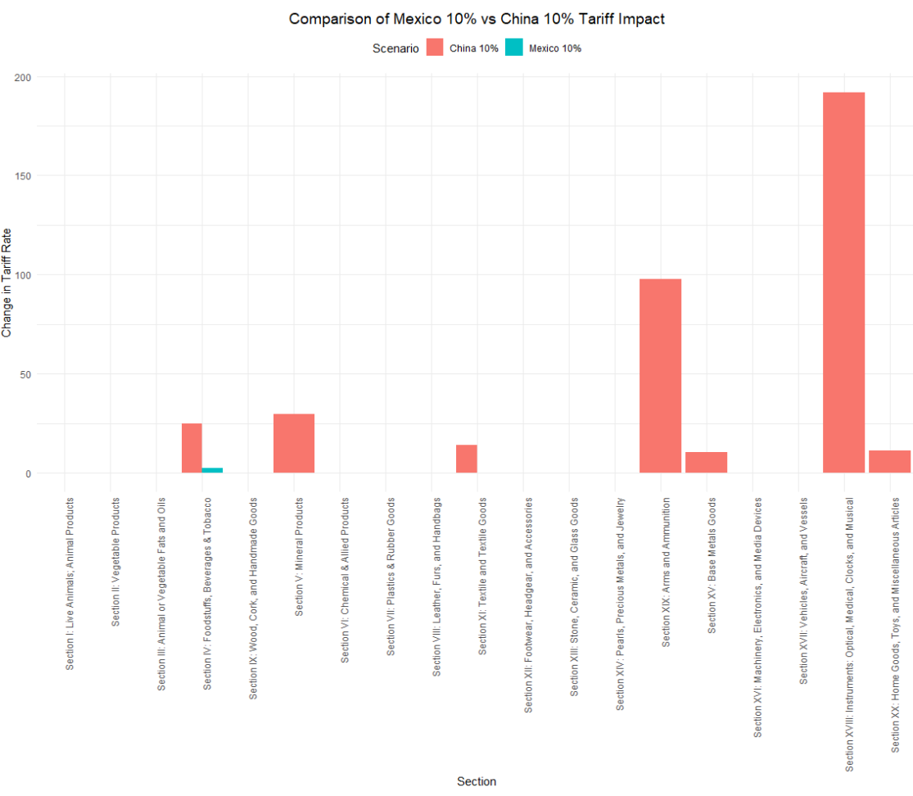
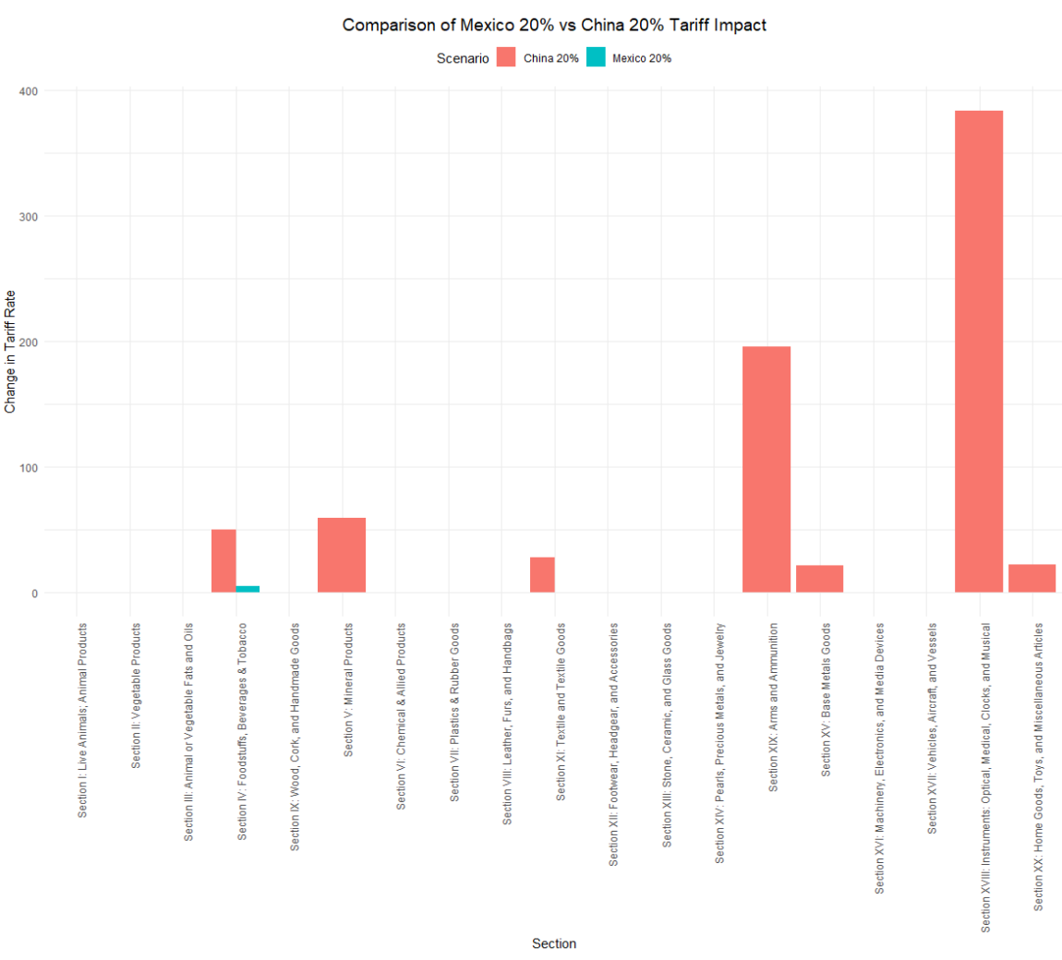
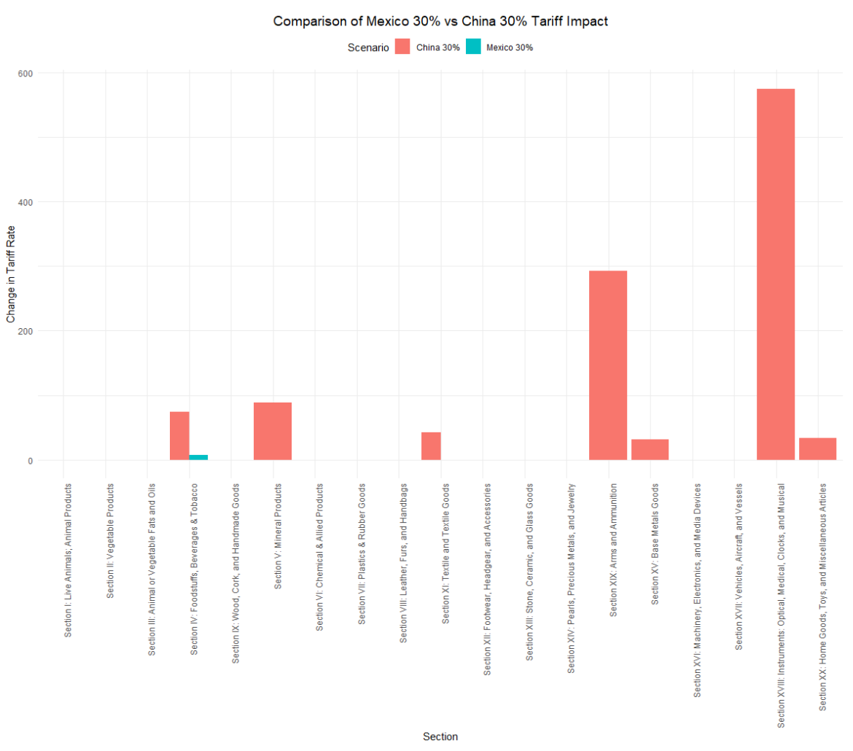
Justification
I selected the scenario-based modeling approach because it allows for flexibility, clarity, and actionability. Flexibility, because I was able to simulate multiple scenarios to assess the impact under varying chapters. Clarity, because aggregating results at the section level, allows for a clearer understanding. Actionability, because by focusing on the differences and the visuals, stakeholders can quickly identify the imports that will be most affected by the increase in tariff.
One advantage of this approach is that it provides structures. The way the charts model and compare the increase across multiple percent scenarios and between the two most imported from countries.
One disadvantage is that it assumes a linear relationship between the tariff increases and costs. Which can oversimplify the real-world impact of these increases.

Data Summary and Implications

Summary of Results
The research question I posed was:
"How will the proposed tariffs impact the Cost of Goods Sold (COGS) for a small company importing from China and Mexico?"
I used a scenario-based modeling to simulate 10%, 20%, and 30% tariff increases for goods imported from both countries. The results revealed the following findings:
Sections with the Highest Impact:
- China: The sections with the most increases in average tariff rates were:
  - Section IV: Foodstuffs, Beverages & Tobacco
  - Section XIX: Arms and Ammunition
  - Section XVIII: Instruments: Optical, Medical, Clocks, and Musical
- Mexico: While tariff increases were observed, their impact was greatly smaller compared to China. Sections such as Textiles and Chemical Products showed an increase, but nothing compared.
Mexico vs. China Comparison:
- The tariff increases on Chinese goods under 20% had a higher percentage increase, compared to Mexican goods due to the additional base tariffs already imposed on China.
- Imports from China would experience a bigger impact on COGS, whereas Mexico's increases are more moderate but still impactful for cost-sensitive goods like tobacco, prepackaged foods, sugars, and processed drinks.
Implications for the Research Question
The implications for the research question suggest that the proposed tariff increases would significantly impact COGS. Especially small businesses that import from China. Those grocery stores that carry favored home sauces, teas, or other branded imports might not be able to afford to import them anymore. They might be left with finding a different way to get the item, not sell them or increase the price.
For example,
In 2024, the United States imported $103,889,345 worth of coffee and tea (Administration, 2024). If tariffs increase:
- 10% Tariff Increase: The new cost would be $114,278,280.
- 20% Tariff Increase: The new cost would be $124,667,214.
- 30% Tariff Increase: The new cost would be $134,056,149.
For the imports from Mexico, the increase seems to impact foods the most. This leads us back to seeing local mom-and-pop stores that rely on affordable, consistent access to imported goods to keep their shelves stocked.
Recommended Course of Action
Based on the results of the analysis, I would recommend
- reducing the dependency on Chinese imports. Looking into neighboring suppliers with a lower rate or no tariff, like Southeast Asia.
- Seeing if suppliers would lock in rates or agree on bulk agreements to minimize the impacts.
Limitation of Analysis
One of the biggest limitations of the analysis is the assumption of a linear relationship between tariffs and costs. In reality:
- A lot of shops will eat the cost of the increase
- Many might also be able to negotiate rates to lower the impact of the increase.
Another limitation is that this analysis relies on average tariff rates per section. This can obscure product-level variations.
Future Study Directions
Two future study directions:
- Look at Specific Products:
- Instead of focusing on grouped sections, we can break it down to specific products which would show exactly which goods are hit hardest by the tariff increases. This could help businesses figure out which items to adjust or prioritize.
- Explore How Businesses Adapt:
- Looking into how businesses might respond to the higher tariff, like:
  - Absorbing the extra costs vs raising prices
  - How customers react to price changes (like buying less or switching to alternatives)

References
Administration, I. T. (2024, December). Office of Consumer Goods Import Data Tools. Retrieved from International Trade Administration: https://www.trade.gov/data-visualization/office-consumer-goods-import-data-tools
Annual Tariff Data, 2023, [Dataset]. (2024). Retrieved from DataWeb: https://dataweb.usitc.gov/tariff/annual
Cost of Goods Sold: How to Use Cost Simulation Model to Calculate the Cost of the Inventory That Is Sold During a Period. (2024, June 6). Retrieved from FasterCapital: https://fastercapital.com/content/Cost-of-Goods-Sold--How-to-Use-Cost-Simulation-Model-to-Calculate-the-Cost-of-the-Inventory-That-Is-Sold-During-a-Period.html
GeeksforGeeks. (2023, December 20). What Are the Tidyverse Packages in R Language? Retrieved from GeeksforGeeks: https://www.geeksforgeeks.org/what-are-the-tidyverse-packages-in-r-language
Harmonized Tariff Schedule. (2024). China Tariffs, [Dataset]. Retrieved from Harmonized Tariff Schedule: https://hts.usitc.gov/reststop/file?release=currentRelease&filename=China%20Tariffs
Harmonized Tariff Schedule of the United States. (2024). Chapter 99. Retrieved from hts.usitc.gov: https://hts.usitc.gov/search?query=990388
Horsley, S. (2024, November 26). Trump's tariffs may be targeted at others — but they could impact you too. Retrieved from NPR: https://www.npr.org/2024/11/26/nx-s1-5206441/trumps-tariffs-china-canada-mexico
Zahn, M. (2024, November 18). Trump's proposed tariffs would raise prices for these products, experts say. Retrieved from abcNEWS: https://abcnews.go.com/Business/trumps-proposed-tariffs-raise-prices-products-experts/story?id=115893557

